

commercial development bank AG
united kingdom branch
berkeley square house, berkeley square, london w1j 6bd, uk
tel: + 442 0 755 888 55
fax: + 443 3 082 801 21


Date:
06 February 2023
From:
REFERENCE number 06/02/2023-UK002/3499-010 (RWA 3499) Œ
Berkeley Square House, Berkeley Square, London W1J 6BD, UK
Bank officer: Roger R. Wilson Esq.
Tel: + 442 0 755 888 55, Fax: + 443 3 082 801 21
uk.branch@bankcdb.com (https://bankcdb.com)
To:
IVANOV YURY (55 0609224 RUS)

(RWA) BANK LETTER (0503-03-000-03143/00)

WE, COMMERCIAL BANK AG,BERKELEY SQUARE HOUSE, BERKELEY SQUARE, W1J 6BD, REPRESENTED BY THE UNDERSIGNED OFFICERS, HEREBY CONFIRM WITH FULL BANK RESPONSIBILITY THAT IVANOV YURY (55 0609224 RUS), WITH ACCOUNT NUMBER 0503-03-000-03499 IS READY, WILLING AND ABLE, AND HAS THE CREDIT FACILITY TO ISSUE BANK GUARANTEE/SBLC/CERTIFICATE OF DEPOSIT (CD) WITH FACE VALUE OF ONE HUNDRED TEN MILLION NINE HUNDRED FORTY THOUSAND EURO (EUR 110,940,000.00) ONLY FOR A PERIOD OF ONE (1) YEAR AND (1) MONTH EXPIRATION PERIOD IN FAVOUR OF BENEFICIARY’S BANK AS PER YOUR INSTRUCTIONS.
WE FURTHER CONFIRM THAT THE /SBLC/CERTIFICATE OF DEPOSIT (CD) IS CASH BACKED, ASSIGNABLE, TRANSFERABLE AND UNCONDITIONALLY CALLABLE UPON MATURITY.
THIS READY, WILLING AND ABLE (RWA) LETTER IS VALID FOR FIVE (5) BANKING DAYS ONLY AS AN OPERATIVE INSTRUMENT AND CAN BE VERIFIED BY COMPLIANCE OFFICERS.

ROGER R. WILSON Esq.  SENIOR MANAGER (RW 611521)  rw.uk.branch@bankcdb.com | AUG SAI SEI  SENIOR TREASURER (AS 605787)  as.uk.branch@bankcdb.com
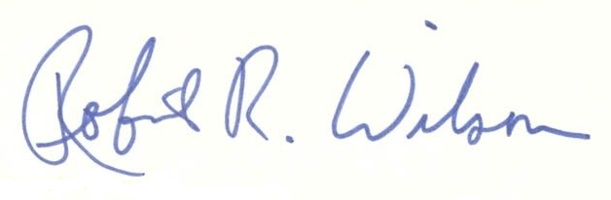   | 

